# **Jetson and Pixhawk Connection and their Method**

**Connection Method**

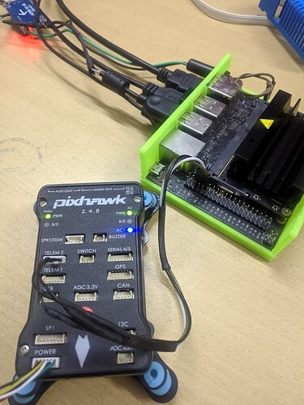 UART Connection:

* Jetson features UART (Universal Asynchronous Receiver/Transmitter) interfaces for serial communication with Pixhawk.
* Pixhawk has dedicated UART ports (e.g., TELEM1, TELEM2) designed for companion computers like Jetson.
* To establish the connection:
* Connect Jetson's UART TX (Transmit) pin to Pixhawk's UART RX (Receive) pin.
* Connect Jetson's UART RX pin to Pixhawk's UART TX pin.
* Connect the ground pins of both devices.

**Communication Protocols**

*UART/Serial Protocol*

* A basic serial communication protocol can be used for data exchange between Jetson and Pixhawk.
* This involves sending and receiving data packets over the UART interface, adhering to a predefined protocol for data formatting and interpretation.
* This method is suitable for simpler applications.

**Jetson:**

* Processes sensor data: Analyzes camera feed and sensor data to understand the environment.
* Runs algorithms: Executes computer vision and machine learning algorithms for tasks like object detection, obstacle avoidance, and path planning.
* Sends control commands: Based on processed data, Jetson transmits navigation commands or waypoints to Pixhawk using the MAVLink.

**Pixhawk:**

* Receives commands: Obtains navigation commands or waypoints from Jetson.
* Controls drone: Translates high-level commands into low-level control signals for motors, servos, and other actuators.
* Maintains stability: Integrates data from various sensors (GPS, IMU, barometer) to stabilize the drone and maintain its desired position and attitude.
* Provides telemetry: Continuously monitors the drone's state and transmits telemetry data back to Jetson for further processing and decision-making.